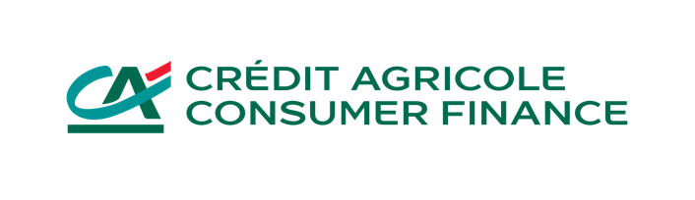

Press release
Paris, October 22nd, 2022

Crédit Agricole Consumer Finance has signed an agreement with the French manufacturer Hopium for the delivery of 10,000 hydrogen-powered vehicles, reinforcing its commitment to green mobility.

Agilauto, Crédit Agricole Group's brand specialised in the financing and sale of cars in France, will offer the French manufacturer Hopium’s hydrogen-powered sedan as part of programs for its private and business customers.

On the Paris Automotive Week, CA Consumer Finance, a subsidiary of the Crédit Agricole Group and leading partner of the French economy, and Hopium, the first French manufacturer of high-end hydrogen-powered vehicles, have signed an agreement for a provisional order of 10,000 vehicles, which production is scheduled to start in 2025.

In addition, Hopium intends to recommend Crédit Agricole Consumer Finance's solutions to its individual and professional customers.

"We are proud to support a French manufacturer of hydrogen-powered vehicles like Hopium and thus to contribute to the transformation towards green mobility of which Crédit Agricole wants to become the leader in France and Europe," says Stéphane Priami, CEO of Crédit Agricole Consumer Finance.

"We are delighted with this agreement with a leading financial partner. This will enable us to strengthen our commercial strategy with a projected order of 1.2 billion euros. This is part of the French and European industrial revival in the production of clean vehicles," says Jean-Baptiste Djebbari, Chairman of the Board of Directors of Hopium.

"I would like to thank Crédit Agricole Consumer Finance’s teams for their trust and support with this groundbreaking order for 10,000 Hopium Māchina. This announcement, which occurs at the closing of the Paris Automotive Week, is a strong signal that underlines the central role of hydrogen in tomorrow's mobility," declares Olivier Lombard, CEO of Hopium.

ABOUT CREDIT AGRICOLE CONSUMER FINANCE

Crédit Agricole Consumer Finance, Crédit Agricole S.A.'s consumer credit subsidiary, distributes (in France, mainly through its Sofinco brand) a wide range of loans and related services through all distribution channels: direct sales, point-of-sale financing (automotive and household equipment) and partnerships. Alongside major retailers and institutions in the 19 countries where it operates, CA Consumer Finance offers its partners flexible and responsible solutions tailored to their needs and those of their customers. Excellence in customer relationships, empowered teams for customers and commitment to society are the pillars that make CA Consumer Finance a group working every day in the interest of its 15 million customers and society. As of 30 June 2022, CA Consumer Finance managed €96.6 billion in outstanding loans.

Learn more: www.ca-consumerfinance.com

Crédit Agricole Consumer Finance Press Department: Claire Garcia - +33 (0)1 87 38 11 81 -
presse@ca-cf.fr

ABOUT HOPIUM

Hopium is the first French manufacturer of high-end hydrogen-powered vehicles and a key player in the field of zero emission mobility. Established in 2019, Hopium was founded by racing driver Olivier Lombard, winner of the 2011 edition of the 24 Hours of Le Mans competition and the most experienced hydrogen racer in the world. The race acted as an open-air laboratory which made it possible for Olivier Lombard and his team to reflect on new mobility solutions to meet contemporary environmental challenges. Bringing together leading partners and experts in the sectors of fuel cells, automotive engineering and advanced technologies, Hopium aims to restore the dialogue between mankind, nature and technology, in a search for a perfect balance.

www.hopium.com
Follow us on Instagram, Linkedin, Youtube, Twitter.

ISIN: FR0014000U63
Mnemonic: ALHPI

HOPIUM’S CONTACTS

Hopium  Communications Director  Edson PANNIER  +33 (0)6 42 80 01 18  e.pannier@hopium.com | VLC  Corporate PR  Valérie LESEIGNEUR  +33 (0)6 68 80 37 35  valerie@agencevlc.com | Actifin  Financial communication  Jean-Yves BARBARA  +33 (0)6 64 11 18 33  jybarbara@actifin.fr | Actifin  Financial PR  Jennifer JULLIA  +33 (0)6 47 97 54 87  jjullia@actifin.fr

